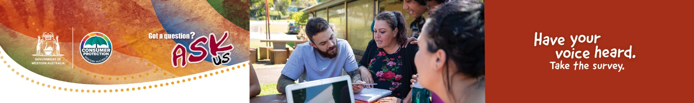
STAKEHOLDER SURVEY

Overview
Thank you for taking part in this survey. Your feedback will help improve the way Consumer Protection shares information to Aboriginal and Torres Strait Islander people about their consumer rights.
Please select the online survey link below to get started. It will take approximately 10 minutes to complete.
Introduction
This is a confidential survey and nothing you share will be linked to you as an individual or organisation in our reporting.

This research is being conducted within the guidelines of the Australian Institute of Aboriginal and Torres Strait Islander Studies (AIATSIS), the Research Society and the Federal Privacy Act.
If you have any trouble completing the survey or have any questions about how the findings will be used, please email askus@dmirs.wa.gov.au (this inbox is monitored during office hours Monday to Friday).

Does your organisation provide a service or product to Aboriginal and Torres Strait Island consumers in Western Australia?
(Required)
Please select only one item

- Yes (GO TO Q2)
- No (Thank you and end survey)
IF NO: Thank you
Thank you for your interest, but unfortunately this time you don't qualify for this research. Hope you have a great day! END SURVEY.

What is the name of your organisation?

What is the postcode where your organisation is located?

Please rate how important the below issues are for Aboriginal people you work with:
(Required)
Please select only one item per row
Subject | Not important | Fairly important | Very imporatant | Not aware of the issue | Unsure
Scams | € | € | € | € | €
Identity theft | € | € | € | € | €
Art and fake art sales (copyright) | € | € | € | € | €
Buying a used car | € | € | € | € | €
Buying a new car | € | € | € | € | €
Car repairs | € | € | € | € | €
Shopping rights (refunds, repairs,returns etc.) | € | € | € | € | €
Paying for funerals | € | € | € | € | €
Tenancy rights (renting a home) | € | € | € | € | €
Debt collectors | € | € | € | € | €
Door-to-door sales people | € | € | € | € | €
Product safety | € | € | € | € | €
Money or finance lenders | € | € | € | € | €
Mobile phones | € | € | € | € | €
Buy now, pay later products | € | € | € | € | €
Are there any other issues not mentioned above?

Would your organisation be willing to share consumer rights information on behalf of Consumer Protection? (Required)
Please select only one item
- Yes
- No
- Unsure

Contact details
Please provide details of the person in your organisation we can contact.
Contact name
Email
Phone number
Please send your completed survey to the FREE reply paid address:

Department of Mines, Industry Regulation and Safety - Consumer Protection
Attn: Community and Media Engagement
Aboriginal Consumers Count Survey
Pre Paid 85353
PERTH WA 6000

Thank you
Thank you for your interest and your feedback. Hope you have a great day!

